Faster waves

Water waves can be made with a plank of wood.
Bigger waves are made by pushing it down harder.
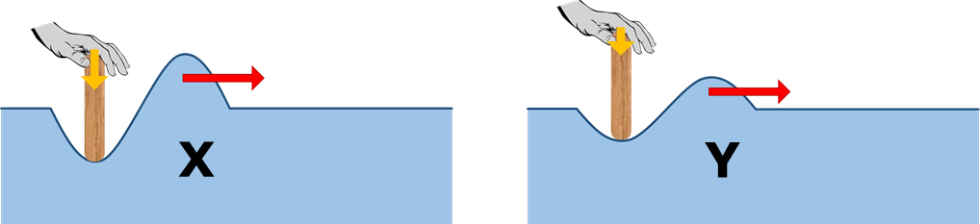

1a. Which wave moves faster through the water?
Put a tick (✓) in the box next to the best answer.
A | Wave X moves faster.
B | Wave Y moves faster.
C | Both waves move at the same speed.

1b. What is the best reason for your last answer?
Put a tick (✓) in the box next to the best answer.
A | Both waves move through the same water.
B | It has more energy.
C | It has more force.
D | Less water needs to be moved.

Waves can be made on a rope by shaking it up and down.
Shaking it quickly makes waves with a high frequency.
Shaking it more slowly makes waves with a lower frequency.
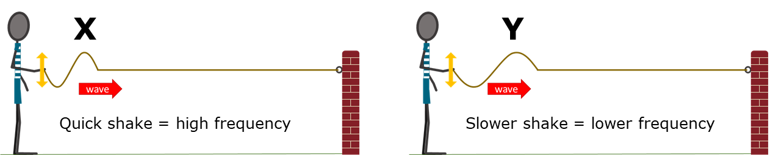

2a. Which wave moves faster along the rope?
Put a tick (✓) in the box next to the best answer.
A | Wave X moves faster.
B | Wave Y moves faster.
C | Both waves move at the same speed.

2b. What is the best reason for your last answer?
Put a tick (✓) in the box next to the best answer.
A | Both waves move along the same rope.
B | It has more energy.
C | It has more force.
D | Less rope needs to be moved.

Physics > Big idea PSL: Sound, light and waves > Topic PSL4: Waves > Key concept PSL4.1: Waves on water and ropes
Diagnostic question
Faster waves

Overview
Learning focus: | A transverse wave travelling across the surface of water (or along a rope) transfers energy, as particles of water (or rope) are successively made to vibrate at right angles to the direction in which the wave travels.
Observable learning outcome: | Compare the speed of transverse waves that have different amplitudes or frequencies to each other and are moving through a common medium.
Question type: | Two-tier multiple choice
Key words: | Wave, transverse wave, amplitude, frequency

What does the research say?
The speed of a mechanical wave depends on the properties of the medium it is passing through and is independent of the wave’s frequency or the size of disturbance (amplitude). In a study of senior high school students (n=324), Tongchai et al (2011) found that fewer than 10% of students held the correct scientific view and that over 70% held the common misunderstanding that wave speed depends on frequency. Wittmann, Steinberg and Redish (1999) found similar results: that over 70% of students enrolled onto a university physics course (n=92) thought the speed of a wave along a rope was affected by the way in which a hand moved to set the wave off.
Some students explained that waves set off with a bigger amplitude moved faster because they had been given more energy or more force. It should be noticed that in a string any sideways force that produces the wave is not pushing along the direction of the wave and so does not accelerate the wave in the forwards direction. Any extra energy is observed by the greater side-to-side movement of the string as the wave progresses.
In Wittmann, Steinberg and Redish’s study (1999) a few students had the misunderstanding that waves with smaller amplitudes travelled faster. The reason they gave was that the smaller pulses could slip more easily through the medium. This is an example of students thinking of the wave as a moving ‘object’, rather than as a perturbation moving through a medium.
Ways to use this question
Students should complete the questions individually. This could be a pencil and paper exercise, or you could use an electronic ‘voting system’ or mini white boards and the PowerPoint presentation. The follow on question will give you insights into how they are thinking and highlight specific misconceptions that some may hold.
If there is a range of answers, you may choose to respond through structured class discussion. Ask one student to explain why they gave the answer they did; ask another student to explain why they agree with them; ask another to explain why they disagree, and so on. This sort of discussion gives students the opportunity to explore their thinking and for you to really understand their learning needs.
Differentiation
You may choose to read the questions to the class, so that everyone can focus on the science. In some situations it may be more appropriate for a teaching assistant to read for one or two students.
Expected answers
1a. C 1b. A
2a. C 2b. A
How to respond - what next?
The speed of a wave through a particular medium is constant. It does not change if the wave has either a higher frequency, or a bigger amplitude. The large proportion of students are likely to disagree with this!
Many students are likely to think that a wave with a bigger amplitude moves more quickly because it requires more force to set it going, and a bigger force gives a bigger acceleration. However, the force applied to give a bigger amplitude is not in the direction the wave is moving in, so it cannot affect the forward acceleration of the wave. Many students are also likely to think that a wave with a higher frequency moves more quickly. Once again the forces vibrating the rope (or water) are not in the direction of the wave.
A few students may think that the wave with a smaller amplitude moves more quickly because it creates a smaller disturbance of the water. They may think that this leads to less resistance to the wave’s forward movement. This answer also suggests the misunderstanding that a steady force is needed to maintain a steady speed.
If students have misunderstandings about how the speed of transverse waves with different amplitudes or frequencies to each other are all the same, if the waves are all moving through a common medium, it can help to demonstrate that this is so using a slinky spring:-
Demonstrating transverse waves on a slinky spring.
A long ‘demonstration slinky spring’ is stretched out along a bench so that it is three or four metres long. The slinky is held by hand at each end and its length kept constant throughout the demonstration. A sharp side-to-side shake at one end should send a distinct wave pulse along the spring, and the pulse is reflected back from the other end.
Sending two pulses along the slinky, one immediately after the other, allows the speed of different types of pulse to be directly compared. If the second pulse follows at the same speed it will neither catch up nor fall further behind the first. Wave pulses of different amplitudes or different frequencies can be directly compared in this way.
Changing the length of the slinky will affect its tension. The tighter the spring is, the faster the waves will travel along it. In water, different depths affect the speed of a wave. Waves coming ashore are atypical because each individual wave changes speed as it moves into shallower water. Shallow water is considered to be a different ‘medium’ to deep water.
The following BEST ‘response activity’ could be used in follow-up to this diagnostic question:
- Response activity: Ripples on a pond

Acknowledgments
Developed by Peter Fairhurst (UYSEG).
Images: Peter Fairhurst (UYSEG), hand: https://pixabay.com/vectors/hands-give-take-brown-white-306885/.
References
Tongchai, A., et al. (2011). Consistency of students' conceptions of wave propogation: Findings from a conceptual survey in mechanical waves. Physical Review Special Topics Physics Education Research, 7(2), 11.
Wittmann, M. C., Steinberg, R. N. and Redish, E. F. (1999). Making Sense of How Students Make Sense of Mechanical Waves. The Physics Teacher, 37, 15-21.

